swiss

Shiva Sankar Modala

2023-03-01

# Load the swiss sample dataset from the built-in datasets (data(swiss))  
data("swiss")

# Perform a basic 80/20 test-train split on the data  
# Creating 80-20 Training Testing Split, createDataPartition() returns the indices  
sampleSize <- floor(0.8 * nrow(swiss))

# Setting the seed to make your partition reproducible  
set.seed(123)  
training_index <- sample(seq_len(nrow(swiss)), size = sampleSize)

# Training data  
training_data = swiss[training_index, ]

# Testing data (note the minus sign)  
testing_data = swiss[-training_index, ]

# Fitting linear model  
# model_fit a linear model with Fertility as the target response,  
linear_model_1 = lm(Fertility ~ ., training_data)

# What features are selected as relevant based on resulting t-statistics?  
# Analyze the t-stat and p-values to select relevant features  
summary(linear_model_1)

##   
## Call:  
## lm(formula = Fertility ~ ., data = training_data)  
##   
## Residuals:  
## Min 1Q Median 3Q Max   
## -10.8850 -3.0226 0.1069 3.3241 14.3459   
##   
## Coefficients:  
## Estimate Std. Error t value Pr(>|t|)   
## (Intercept) 67.96084 10.55947 6.436 3.57e-07 ***  
## Agriculture -0.22216 0.08167 -2.720 0.010593 *   
## Examination -0.22362 0.27124 -0.824 0.416003   
## Education -0.89779 0.18977 -4.731 4.64e-05 ***  
## Catholic 0.13664 0.03446 3.965 0.000402 ***  
## Infant.Mortality 1.13267 0.38546 2.939 0.006177 **   
## ---  
## Signif. codes: 0 '***' 0.001 '**' 0.01 '*' 0.05 '.' 0.1 ' ' 1  
##   
## Residual standard error: 6.54 on 31 degrees of freedom  
## Multiple R-squared: 0.7656, Adjusted R-squared: 0.7278   
## F-statistic: 20.25 on 5 and 31 DF, p-value: 6.076e-09

# What are the associated coefficient values for relevant features?  
# coefficient values for relevant features   
linear_model_1$coefficients

## (Intercept) Agriculture Examination Education   
## 67.9608389 -0.2221646 -0.2236157 -0.8977904   
## Catholic Infant.Mortality   
## 0.1366393 1.1326696

# Predict out-of-sample  
predict_out_of = predict(linear_model_1, testing_data, type = "response")

# Evaluate error  
actual_data = testing_data[, "Fertility"]  
cat("Out-of-Sample test MSE for regular linear model = ", mean((predict_out_of - actual_data)^2))

## Out-of-Sample test MSE for regular linear model = 93.27207

library(glmnet)

## Loading required package: Matrix

## Loaded glmnet 4.1-6

# Lambda vector of 101 elements Ranging from 0 - 100000  
lambda_seq = 10^seq(5, -5, by = -.1)

# Extract x and y from training data  
y = training_data$Fertility  
x = model.matrix(Fertility~. ,training_data)[,-1]

# Use cross-validation (via cv.glmnet) to determine the minimum value for lambda - what do you obtain?  
# Cross-validation to perform minimum lambda  
cross_validation_fit = cv.glmnet(x, y, alpha = 1, lambda = lambda_seq)  
optimal_lambda = cross_validation_fit$lambda.min  
cat("Optimal Lambda = ",optimal_lambda)

## Optimal Lambda = 0.0003162278

# Perform a lasso regression using the glmnet package  
# Fitting Lasso Regression with optimal lambda  
model_fit = glmnet(x, y, alpha = 1, lambda = optimal_lambda)

# Plot training MSE as a function of lambda  
# Plot the model  
plot(cross_validation_fit)

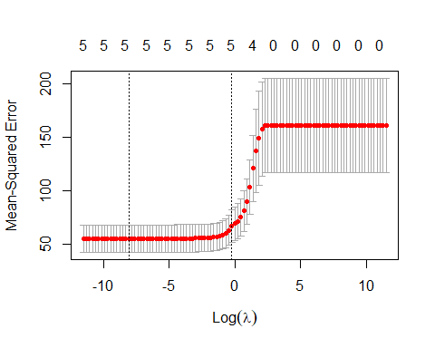

# Coeff. of Lasso Regression  
coef(model_fit)

## 6 x 1 sparse Matrix of class "dgCMatrix"  
## s0  
## (Intercept) 67.9556030  
## Agriculture -0.2221546  
## Examination -0.2229399  
## Education -0.8981031  
## Catholic 0.1366884  
## Infant.Mortality 1.1324147

LassoReg_x = model.matrix(Fertility~. ,testing_data)[,-1]

# Predicting on out-of-sample test data  
LassoPredict = predict(model_fit, s = optimal_lambda, newx = LassoReg_x)

# Evaluate error  
actual_data = testing_data[, "Fertility"]  
cat("Out-of-Sample test MSE with Lasso Regression = ", mean((LassoPredict - actual_data)^2))

## Out-of-Sample test MSE with Lasso Regression = 93.27388

cat ("After the Lasso, we are supposed to get some coefficient perfectly equal to zero, however we aren't getting such results, rather the coefficients have shrunk to some extent and the out-of-sample MSE has raised a little bit from 93.27207 to 93.27388. Lasso usually performs variable selection, but in this case it is performing shrinkage.")

## After the Lasso, we are supposed to get some coefficient perfectly equal to zero, however we aren't getting such results, rather the coefficients have shrunk to some extent and the out-of-sample MSE has raised a little bit from 93.27207 to 93.27388. Lasso usually performs variable selection, but in this case it is performing shrinkage.